Name___________________________________

Quick Quiz

**Unit Rate 3**

Identify the unit rate:

1. 2 inches of snow in 4 hours 2.

**_________ inches per hour unit rate =_________**

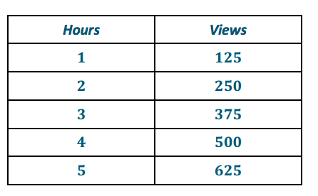

3. 4. 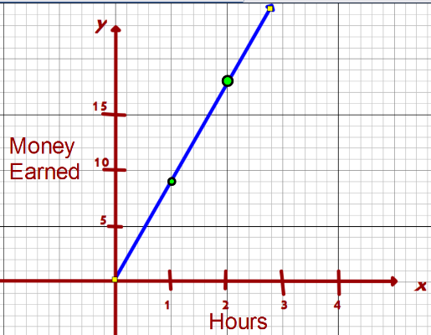

**$________**

**per hour**

**_________ views per hour**

____________________________________________________________________________

Corrections

**Unit Rate 3**

Identify the unit rate:

1. 2 inches of snow in 4 hours 2.

**_________ inches per hour unit rate =_________**



3. 4. 

**$________**

**per hour**

**_________ views per hour**